Submission:

1. Click File -> Export… -> General -> Archive File, then choose both your server and PA2 project, mark “Resolve and export linked resources” option, name your archive file as LastName_FirstName_CSCI201_Assignment2, and your name needs to match the one on DEN:

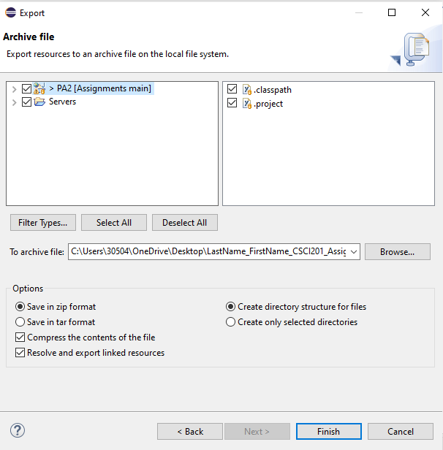

1. Unzip the archive file and inspect its contents. You need to make sure your code, a README file describing the deployment steps, the sql script to initialize your database, and any jars your project depend on are in the archive.
2. Create a new empty workspace at a different directory in eclipse. Choose File -> Open Projects from File System -> Choose your archive from step 1, and choose only importing the PA2 project.
3. Create a new server based on your tomcat server, right click on the created server, then go to Show in -> System Explorer, and the server directory will open. Unzip your submission zip manually, go into the server folder in that unzipped folder, and copy the “Tomcat v9.0 Server at localhost-config” folder into your server folder in the new workspace.
4. Run your sql setup (Must starts with “DROP DATABASE IF EXISTS ****; CREATE DATABASE ****;” to do a clean install of your schema), start your application, and verify that you can still run the project.
5. Go to DEN and submit the archive.